Siege of Augusta 2018: Kings of War GT

# Overview

On January 12-14, The Siege of Augusta, one of the South’s longest running war-gaming conventions, will host the Siege of Augusta Kings of War GT. This will be the first U.S. Masters qualifier in the 2018 season for both the Southeastern and Mid-Atlantic Regions. Registration for the convention is $45 (pre-registration is only $40) and this includes not only entry into the Kings of War tournament but access to a wide array of events and open gaming opportunities over the course of the weekend. We will also be hosting a Kings of War historical tournament on Friday night. All of this is included in the price of admission. To register, visit the Siege of Augusta webpage (registration will open soon): <http://siege-of-augusta.org/attendee-registration/>

Finally, you can find information and updates about the tournament by visiting our Facebook group or my twitter feed. Please join the group and let us know if you are coming:

Facebook: <https://www.facebook.com/groups/1723893084602303/>

# Location

The tournament will be held at the Siege of Augusta gaming convention in Augusta, GA. The Siege of Augusta is an HMGS Mid-South-sponsored convention dedicated to miniature tabletop gaming and has been the CSRA’s premiere gaming event for 25 years. It will be held at the Double Tree Hilton in Augusta, GA:

Double Tree Hilton

2651 Perimeter Park

Augusta, GA 30909

Information regarding the block rate will be coming soon.

# Schedule

Saturday, January 14

8:30-8:45 ~ Registration and Pairings

8:45-10:55 ~ Game 1

11:00-1:10 ~ Game 2

1:10-2:10 ~ Lunch

2:10-4:20 ~ Game 3

4:30-6:40 ~ Game 4

7:00 ~ Open Gaming at Convention or Group Dinner with Food, Drinks, and Pool at the best sports bar in Augusta (Robbie’s Sports Bar, 2834 Washington Rd, Augusta, GA 30909)

Sunday, January 15

8:30-8:40 ~ Registration and Pairings

8:40-10:50 ~ Game 5

11:00-1:10 ~ Game 6

1:10-1:45 ~ Lunch (while we prepare awards)

1:45-2:00 ~ Award and Prize Presentation

# Rules

This is a 2250 point event for Kings of War 2nd Edition. Army composition rules follow the core rules. Allies from a single army list are allowed as governed by the rules and the *Clash of Kings* 2018 modifications that can be found on the Siege of Augusta Facebook group. Armies from the *Core Rulebook* and *Uncharted Empires* are allowed as are special units and formations from *The Destiny of Kings* and *Edge of the Abyss*. Armies from the *Kings of War Historicals* supplement are also allowed with one exception: historical units may not take or be taken as allies (they may, however, use the mythical creatures and veteran abilities lists from the *Historical* rulebook).

Submitting the lists to [rrbrando.rb@gmail.com](mailto:rrbrando.rb@gmail.com) by midnight eastern time on January 1 will gain bonus sportsmanship points. We need the lists by January 1 to give us the opportunity to check them before the event.

# Terrain

There will be three standardized terrain set-ups at the event. Efforts will be made to ensure that 25% of the board is covered by some terrain. Heights are as follows:

Water/Lava/Slime Field: 0 Buildings of all Types: 5

Fences/Walls/Rocks: 1 Forests: 5

Hills: 2

For the purpose of this event, height 0 terrain will only provide cover to units within it.

# Chess Clocks

Chess clocks will not be required for this event; however, all players are encouraged to keep pace of play in mind. If you feel your opponent is taking an undue amount of time, please call the T.O. over, and a chess clock will be provided for the rest of that game. Also, if a player fails to complete the whole game (including a turn 7 if necessary), that player will be expected to use a chess clock for the rest of the tournament.

# Army Appearance

While we believe that painted armies improve the quality of the game and add to both player’s enjoyment, painted armies are not required to participate. While there will be a painting component inside the best overall standings, players without painted armies are eligible to win any award.

Base size is very important in Kings of War. For that reason, all units must meet the rules for base sizing found in the core rulebook. Multi-basing is allowed as long as the footprint is accurate. The general standards for the number of models on a multi-base is provided in the current FAQ, but for this tournament, as long as the bases are the correct size and the element appears to be full, minimum model count guidelines will not be enforced.

Proxies are allowed; however, please make sure that the unit type is communicated to your opponent. You should make an effort to have the miniature type correspond to the unit type (i.e. no monsters standing in for infantry units; flyers should have wings; shooting units should have bows).

# Force Lists

Please bring at least six copies of your list to the tournament: five for your opponents and one for yourself. Each list should clearly identify the units in the army, any items they contain, and the point cost for each. We encourage all players to use Kings of War Easy Army as it is a quick and accurate way to make lists. Make sure you are on the Clash of Kings page: <http://kow2.easyarmy.com/clash-of-kings.aspx>

They also have a historical page for anyone planning on using one of those lists: <http://kowh.easyarmy.com/>

# Battle Points (90 Points)

The winner of each round will be determined by the completion of one of the following scenarios. Each scenario scores 15 points in a win and 10 points in a draw and 5 points for a loss. The scenarios are as follows:

Round 1: Pillage

Round 2: Invade

Round 3: Eliminate

Round 4: Push

Round 5: Scour

Round 6: Control

# Kill Point Margin (30 Points)

In addition to the points provided for winning the scenario, players also earn points for their ability to route opponent units while keeping their own units intact. The chart following chart shows how those margins affect the score:

|  |  |  |
| --- | --- | --- |
| Point Differential | Player with Most Points | Player with Fewest Points |
| 0-299 | 0 | 0 |
| 300-599 | 1 | -1 |
| 600-1099 | 2 | -2 |
| 1100-1599 | 3 | -3 |
| 1600-1999 | 4 | -4 |
| 2000-2250 | 5 | -5 |

# Painting Scores (30 Points)

Painting Scores will be determined using the Painting Checklist below.  The judges will place the armies into one of four categories and then add the bonus points on top of that.

We encourage great looking items on the table but prefer to give the painting prize to the person responsible for the army. That said, we understand that many players have prized commission pieces or models gifted from friends. Because of this, we are setting the benchmark for prize awards at having painted the majority of models oneself. If your army does not meet this benchmark, please let us know before the tournament begins. You will still get the points for overall but will not be eligible for best painted.

Painting ability Base Points

--------------------------------------------------------------------------

1. Unpainted Models

If you have any unpainted in your army, you will be placed in this category and earn 0 points.  No other points can be earned for painting aside from the nameplate score.  Please note that ALL models must have some paint on them to avoid this category.

--------------------------------------------------------------------------

2.  Bare Minimum Painting

Armies with blocked colors with no attempts at shading, highlighting, or washing will be placed into this category and earn 15 points. This could also be a more standard level GT army with no basing or it could be a well-painted proxy army that is not well matched.

----------------------------------------------------------------------------

3.  Standard GT Army Points

This category represents standard GT level painting. Everything is neat, there are some elements of highlighting or shading. This category generally seeks a base coat + a wash + a highlight along with a standard level of basing. Armies in this category will receive 20 points.

--------------------------------------------------------------------------

4.  Well-Executed GT Army Points

This army is exceptionally well painted or is a standard army with many impressive features such as architectural elements in basing or many conversions. Armies in this category will receive 25 points.

------------------------------------------------------------------------------

5 Bonus Points

These are extra features that we believe go beyond expectations of even a well-executed GT army. For the purpose of the painting award, any number of these may be added to your score; however, for purposes of tournament scoring, painting scores are capped at 30.

A. Very High quality and detailed shading, highlighting and blending (1 Point)

B. Large number of high quality, detailed conversions that require heavy green stuff use or sculpting (1 Point)

D. Detailed freehand work (1 Point)

E. Clear army theme reflected in appearance (1 point)

F. A display board (1 point)

G. An elaborate display board that clearly ties with the army’s appearance (1 point)

H. A nameplate that adds to the army in some way (pictures, engraving, etc.) (1 point)

I. Some themed narrative or artistic piece that somehow tells the story of the army (1 point)

J. Detailed attention to model details such as eyes, gemstones, etc. (1 point)

K. Very elaborate basing (action poses, dioramas, etc.) (1 point)

L. Impressive banners that go beyond normal standards in some way. (1 point)

M. 75% of army’s models are manufactured by Mantic.

N. “Wow factor.” This is a catch-all category for anything not covered above that catches the judge’s eye. (1 point)

# Sportsmanship Scores (33 Points Maximum)

At the end of each game you will answer the following two questions. Each “yes” answer will score 1 point for your opponent: Did your opponent arrive on time and prepared to play?. Were you treated with respect by your opponent? Did your opponent maintain a reasonable pace of play or use a chess clock?

At the end of the tournament each player will award medals to three of their opponents. Each “medal” will garner the following points for your opponents.: Gold Medal: 3 Points, Silver Medal: 2 Points, Bronze Medal: 1 Point

In addition, all players can earn the following points:

1 Point for paying registration by December 31

1 Point for turning in list by January 1

1 Point for submitting a player’s choice vote for painting

# Awards

The following awards will win trophies or other tangible awards:

**Best General:** Scenario + Kill + Objectives (Tiebreaker: Sports)

**Best Overall**: Scenario + Kill + Objectives + Paint + Sports (Tiebreaker: Sports)

**Best Sportsmanship:** Sports (Tiebreaker: S+K+O)

**Best Painted:** Paint (Tiebreaker: S+K+O)

**Award to Be Named** **Later:** Exact middle of the pack in S+K+O

**Wooden Spoon**: The player whose army had the most difficulty during the weekend

**Player’s Choice Painted**: Most player votes for “best army”

**Best Club**: The club whose top 3 players have the lowest combined overall placing.

**Bragging Rights**: The top 3 players from the SE region will be compared with the top 3 players from the MA region in terms of overall placing. The group with the lowest combined placing will each receive the Bragging Rights award, and their region will receive the acclaim that goes with it.

We will also provide “best in faction” awards to the player whose overall score is highest for each faction.

# Kings of War Friday Historical Event

We will be hosting a Friday night even for historical armies only. This event will use all of the standard Kings of War Historical Rules and will be played at 1500 points. Mythical allies will not be allowed for this event. Because historicals are played at such a wide array of sizes, all miniature sizes are allowed at this event. We just ask that the base/element size be correct for the unit type and that the units resemble the types of units they are representing. This event will not use soft scores. This event will follow this schedule:

4:30-4:45 ~ Registration and Pairings

4:45-6:15 ~ Game 1

6:15-7:45 ~ Game 2

7:45-9:00 ~ Game 3

9:00-9:15 ~ Crowning of the Champion

Sponsors:

Please consider supporting our sponsors by using them on future projects. If you do, please let them know that you appreciate them supporting the Siege. This will make them more likely to support future events and will thank them for supporting our scene:

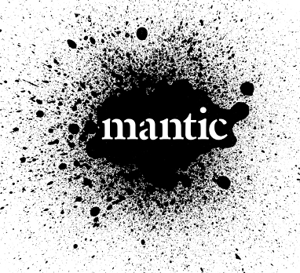Mantic Games: <http://www.manticgames.com>

Wartime Hobbies: <http://www.boltaction.us/store/c1/Featured_Products.html>

 Atomic Empire Comics and Games: <http://www.atomicempire.com>

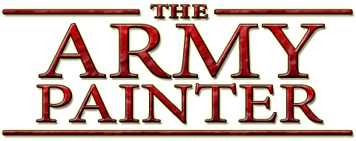 The Army Painter: <https://www.thearmypainter.com>

Antimatter Games: <http://antimatter-games.com>

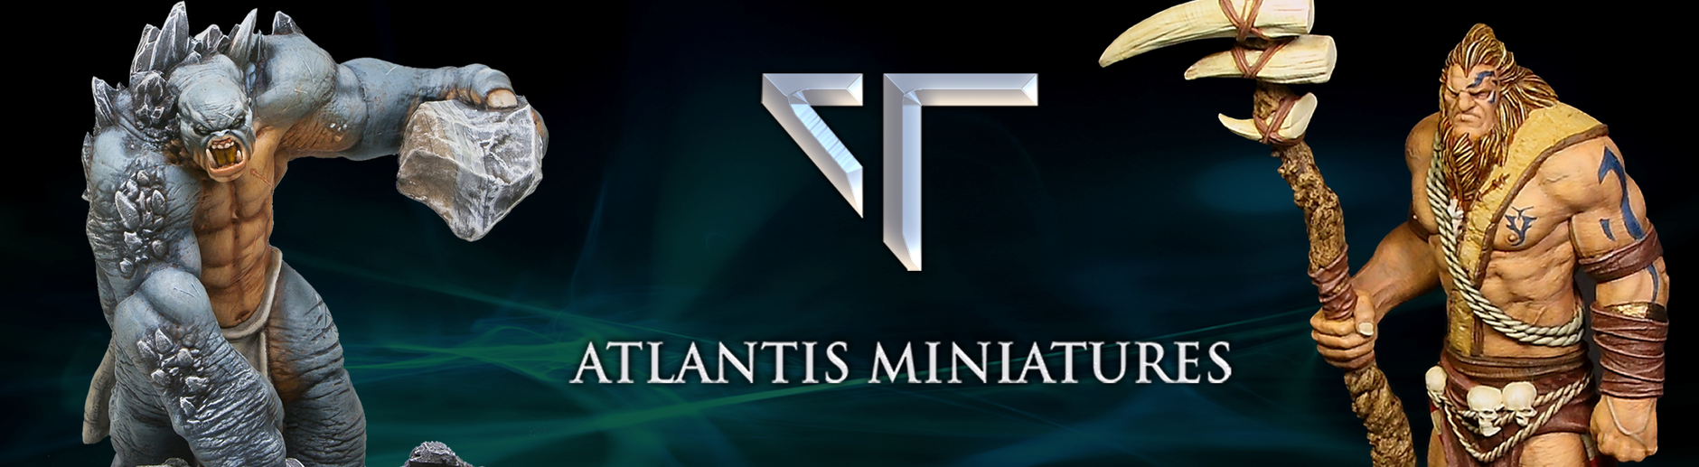 Atlantis Miniatures: <https://www.atlantisminiatures.com>

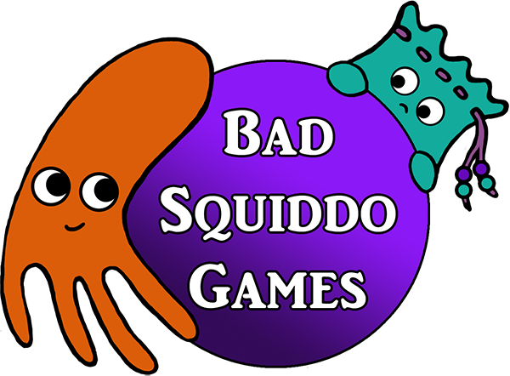 Bad Squiddo Games: <http://badsquiddogames.com>

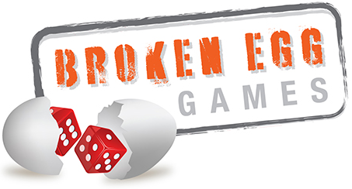Broken Egg Games: <http://www.brokenegggames.com>

Cigar Box Battle Store: <http://cigarboxbattlestore.bigcartel.com>

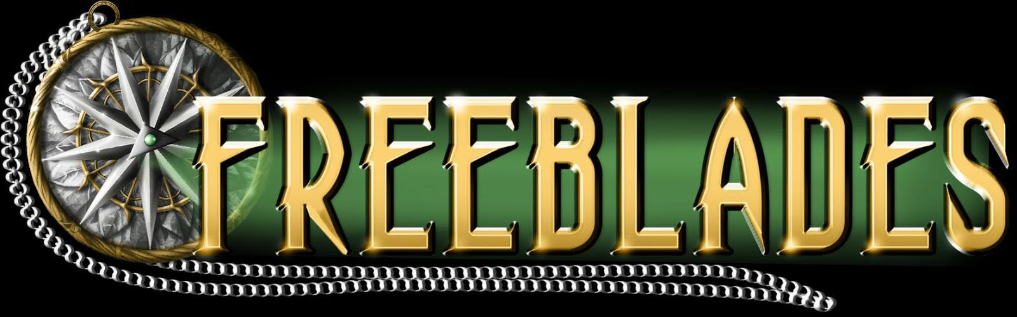 DGS Games: <https://www.dgsgames.com>

Green Stuff World: <http://greenstuffworld.com>

Ironheart Artisans: <https://ironheartartisans.com>

 Kromlech Games: <http://www.kromlech.eu/go.live.php>

Laughing Corpse Gaming Club and the TNT GT: <https://www.facebook.com/Gamingconvention/>

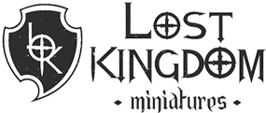Lost Kingdom Miniatures: <http://lostkingdomminiatures.com/en/>

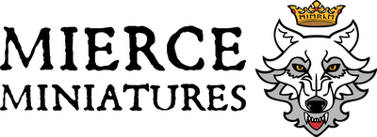Mierce Miniatures: <http://mierce-miniatures.com/index.php>

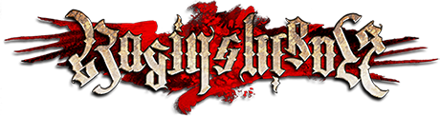Raging Heroes: <https://www.ragingheroes.com>

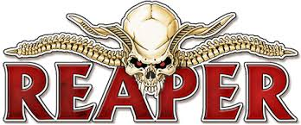Reaper Miniatures: <https://www.reapermini.com>

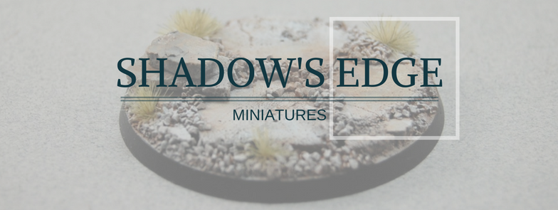Shadow’s Edge Miniatures: <http://shadowsedgeminis.com>

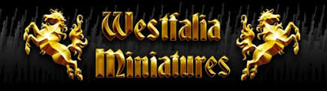Westfalia Miniatures: <http://westfaliaminiatures.com>

 Winsor & Newton: <http://www.winsornewton.com/na/>